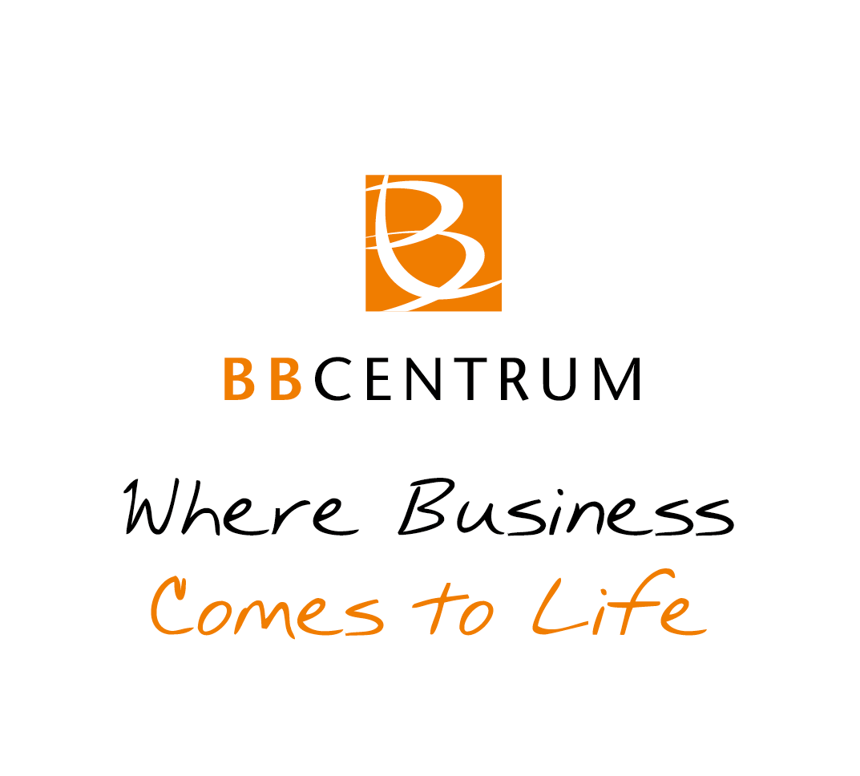

**PRESS RELEASE** Prague, 12th February 2016

# Amorous BookBooth in BB Centrum

**On Valentine’s Day** [**BB Centrum**](http://www.bbcentrum.cz/) **presented a new look for its BookBooth in Baarův Park. The successful public library frequently changes the books it loans and now it is offering books with a romantic theme to its readers until the end of February. Not only readers of romance novels will come into their own, but also those who enjoy true-life stories.**

From Friday, February 12th until the end of the month visitors to [Baarův Park](http://www.bbcentrum.cz/cs/projekty/baaruv-park/), BB Centrum employees and tenants, and the public at large can borrow or, on the contrary, bring books with a romantic theme to the BookBooth in Baarův Park. On this occasion the BookBooth has a new look and those interested in romantic literature will definitely not overlook it.

*“The BookBooth was placed in BB Centrum in August of last year and it has met with huge success, which we are very pleased about. The great interest in books has inspired us to having themes connected to some of the important days of the year,”* stated Kristýna Samková, the Head of Marketing of PASSERINVEST GROUP. “*Thus we extended Valentine’s Day to all of February and, of course, we would be glad if the books there find their way to their readers and, on the contrary, new books will be added to the BookBooth. That is the principle of the library…“*

The rules for using the BookBooth remain the same. Readers can borrow and take away any book they choose, free of charge. No loan period is specified for the borrowed books; they can be returned at any time. Thus the reader can peruse the book at his or her leisure and does not have to worry about late return fines. And if the readers want, they can, on the contrary, enrich the BookBooth with a title from their own library, thereby sharing it with other enthusiastic readers.

BB Centrum is one of the largest and most successful development projects in the Czech Republic. It is not, however, just an office centre - BB Centrum is also a multifunctional complex with all the civic amenities. It offers opportunities for living and for working as well as leisure, educational and cultural activities. At the beginning of February two new electric buses were added to the BB1 and BB2 bus routes connecting BB Centrum and the Budějovická metro station. They are the first electric buses deployed into regular use in Prague mass transit, plus they can be used completely free of charge by visitors to BB Centrum.

You can find news and current information about the events in BB Centrum at [http://www.facebook.com/BBCentrum](https://cs-cz.facebook.com/pages/BB-Centrum/730141167045202).

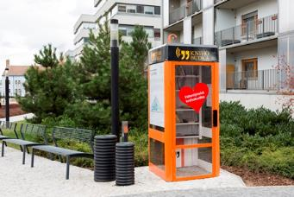

Amorous BookBooth in BB Centrum

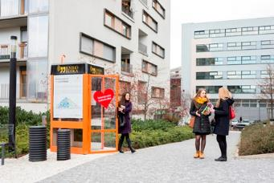

Amorous BookBooth in BB Centrum

For more information and photographs in print quality please contact:

Kristýna Samková**,** Marketing manager

**PASSERINVEST GROUP, a.s.**

Tel.: (+420) 221 582 111, fax: (+420) 222 515 521

Mobil: (+420) 602 186 708

E-mail: [Kristyna.Samkova@Passerinvest.cz](mailto:Kristyna.Samkova@Passerinvest.cz)

www.passerinvest.cz, [www.bbcentrum.cz](http://www.bbcentrum.cz)

Marcela Štefcová

**Crest Communications a.s.**

Tel.: (+420) 222 927 125

Mobil: (+420) 731 613 669

E-mail: marcela.stefcova@crestcom.cz

**About the Developer**

**PASSERINVEST GROUP, a.s.,** founded in 1991 by Radim Passer, is a purely Czech development and investment company whose name is associated in particular with the **BB Centrum** multifunctional complex in Prague 4 - Michle. With this project, the most successful and extensive Czech project of its type, the company has built its excellent reputation both at home and at the international level. Contributing to this is not only the high quality of the projects completed to date, but also its high level of service, its sense of fair play, its positive relationship with the tenants and users of its buildings, and its sense of responsibility towards society and the environment. **PASSERINVEST GROUP**’sportfolioincludes other interesting development projects.

**About the BookBooth project**

The non-profit **BookBooth** project originated in 2013 as a volunteer activity of Monika Serbusová and Pavel Železný. The goal is to create a free public library by converting old phone booths. At the current time it works on the principle of sponsorship/adoption, where the BookBooth team, after coming to an agreement with the sponsor, reconstructs an old booth in various styles and designs or remotely helps another team of volunteers with the modification and implementation. The logo and text of the BookBooth’s sponsor or adopter is always placed on one side of the booth and on the other side there is space for the free presentation of a local non-profit organisation.